There is NO official lrp package than can be used.

grad-cam can in fact be used with transformers with the "official" package.

grad-cam can be used with "vision" transformers with the "official" package.

grad-cam can't be used with classical ml

Lime and SHAP don't care about the type of model.

grad-cam works only on pytorch

https://github.com/albermax/innvestigate is an lrp implementation using keras

https://github.com/chr5tphr/zennit is an lrp implementation using pytorch

https://github.com/jacobgil/pytorch-grad-cam is a grad-cam pytorch implementation

Both lrp and grad-cam have relatively complete implementation for CNNs

Both can be used in NLP but with CNN models only (no attention-based or transformer-based models)

Both have incomplete implementation in case of attention-based or transformer-based models

Both LRP and grad-cam CAN be used with attention-based or transformer-based models but we will need to implement them from scratch

logistic regression need much more iterations than the default value to successfully converge (now it is set to 10,000 iterations maximum)

Shoutout for <https://github.com/yidinghao/interpreting-nlp/tree/master> for saving the day and enabling us to do the LRP

Embedding needs to be done in batches on GPU

logistic regression with light stemming vectorizer:

logistic regression with root stemming vectorizer:

Naïve bayes with Light Stemming vectorizer:

Naïve bayes with root Stemming vectorizer:

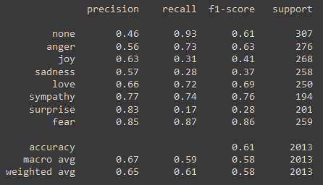

logistic regression with light stemming embedding:

logistic regression with root stemming embedding:

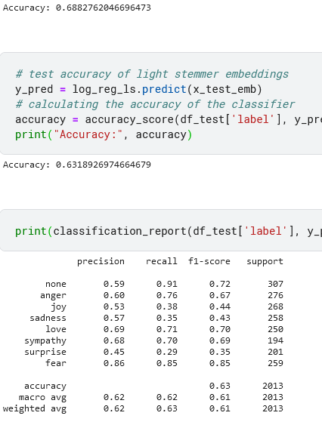

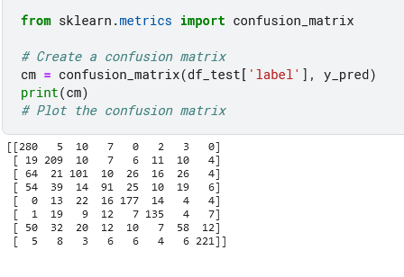

Examples:

None predicted correctly:

We can observe that the prediction is true, but only because of the “الاوليمبياد” word

None predicted incorrectly

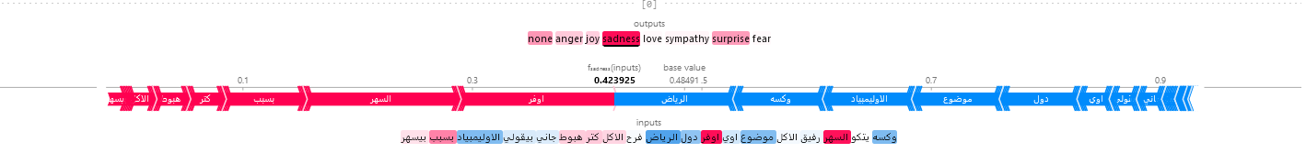

anger predicted correctly



anger predicted incorrectly

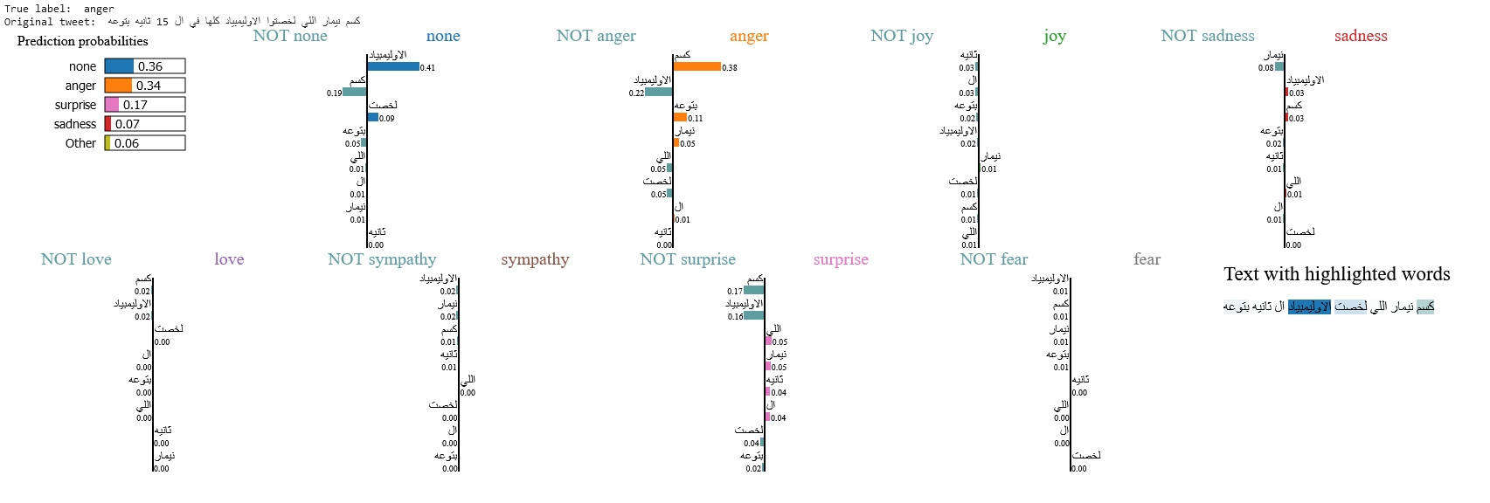

joy predicted correctly



joy predicted incorrectly

In this case the predicted label is different than the true label but the model, surprisingly, is not actually that wrong.

sadness predicted correctly

sadness predicted incorrectly

love predicted correctly

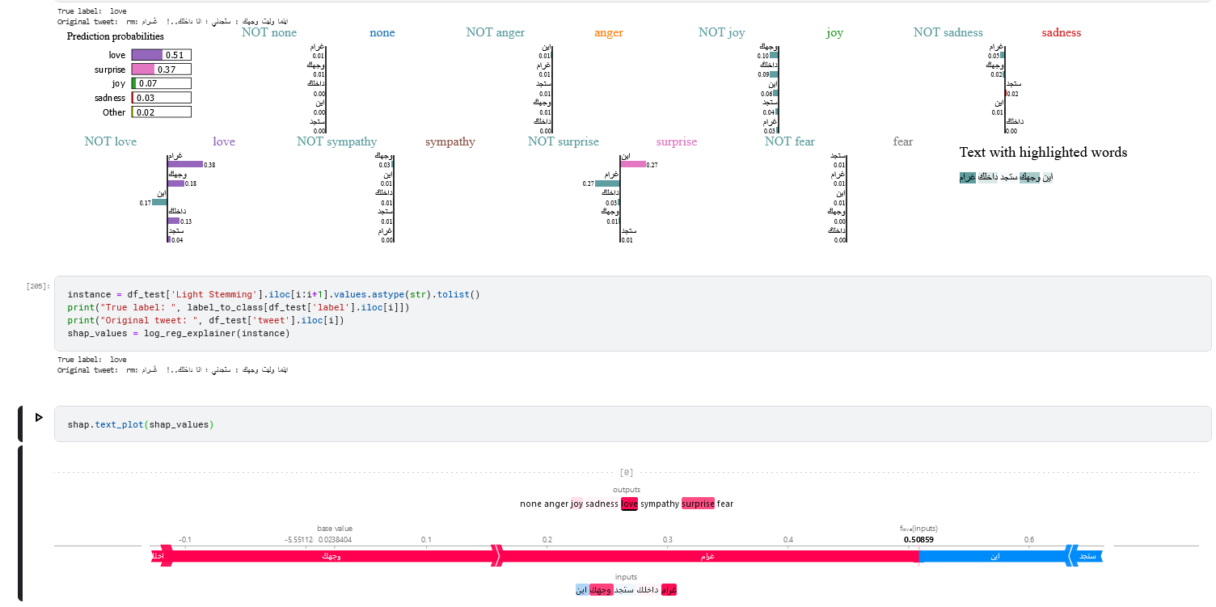

love predicted incorrectly

sympathy predicted correctly

sympathy predicted incorrectly

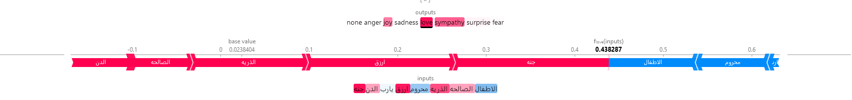

Surprise predicted correctly

Surprise predicted incorrectly

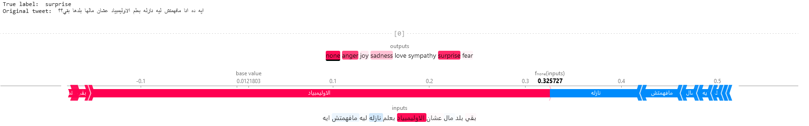

“الاوليمبياد” strikes once more.

Fear predicted correctly

Incorrect use of emojis

Fear predicted incorrectly



Notes:

1. Light stemming is much better
2. WITH tokens is actually better than without
3. Some words(“الاوليمبياد”) mess up the prediction
4. Some emotions are close to one another and have a high chance of being confused together (ex. Sympathy and sadness, love and joy, sadness and anger, none and all)
5. Some samples are labeled incorrectly
6. Some samples’ labels ambiguous.
7. Sometimes samples are labeled correctly for weird reasons